Lab 6 – Quick Reference: Jumper connections and Pin Access for Talking Measurements

Contents

Buffer PCB 2

Jumper Connection to play music. 2

Pins to access to take measurements. 3

Preamp and Mixer PCB 4

Mixing Audio with the Microphone {Buffer PCB , and Preamp and Mixer} 4

Pins to access to take preamp measurements. 5

Pins to access to take mixer measurements. 7

Treble and Bass PCB 8

Complete Stereo Amplify with Treble and Bass {Buffer PCB, Mic. Preamp and Mixer PCB, and Treble & Bass PCB} 8

Pins to access to take Treble measurements. 9

Pins to access to take Bass measurements. 10

# **Buffer PCB**

## Jumper Connection to play music.

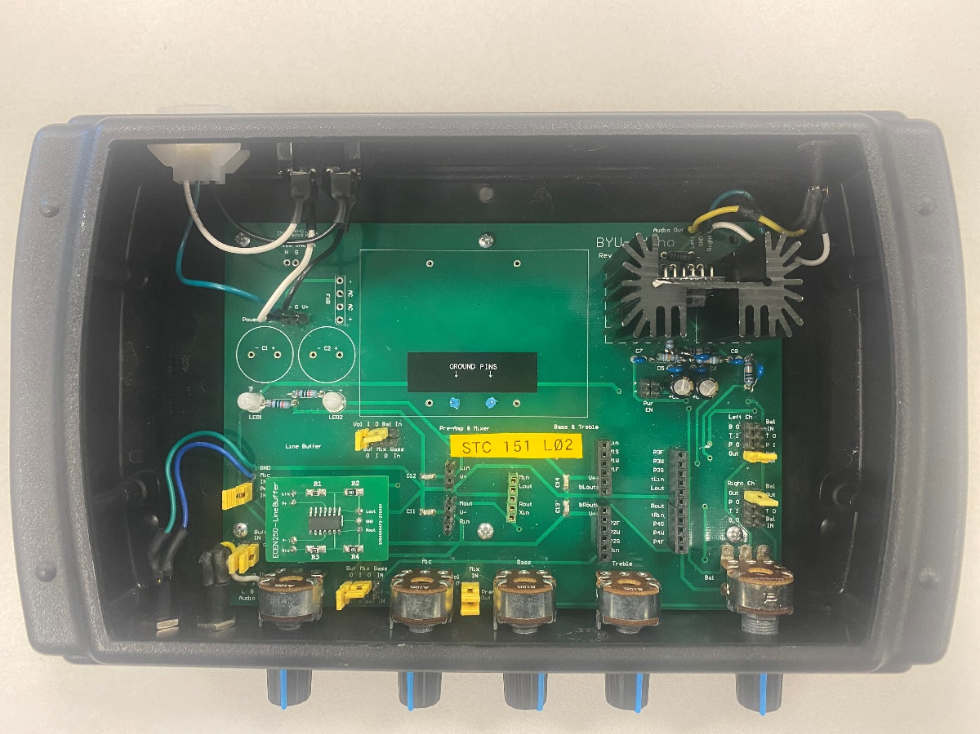

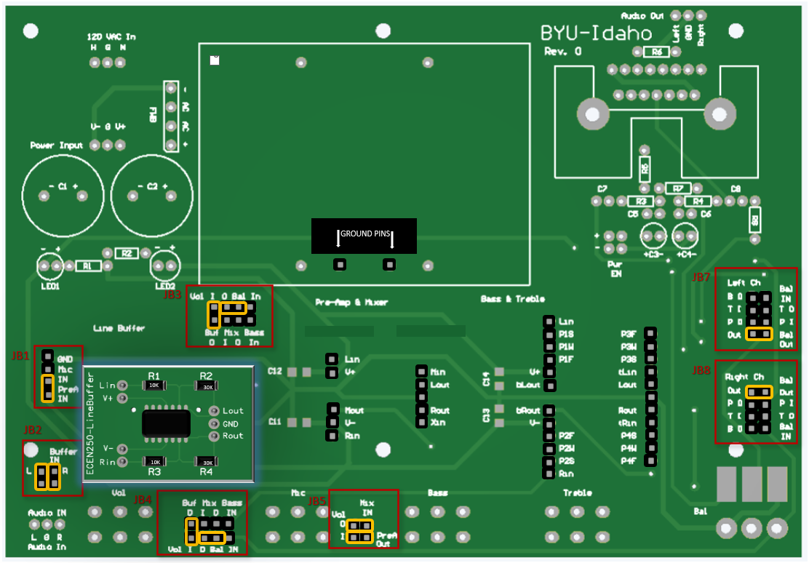

## Pins to access to take measurements.

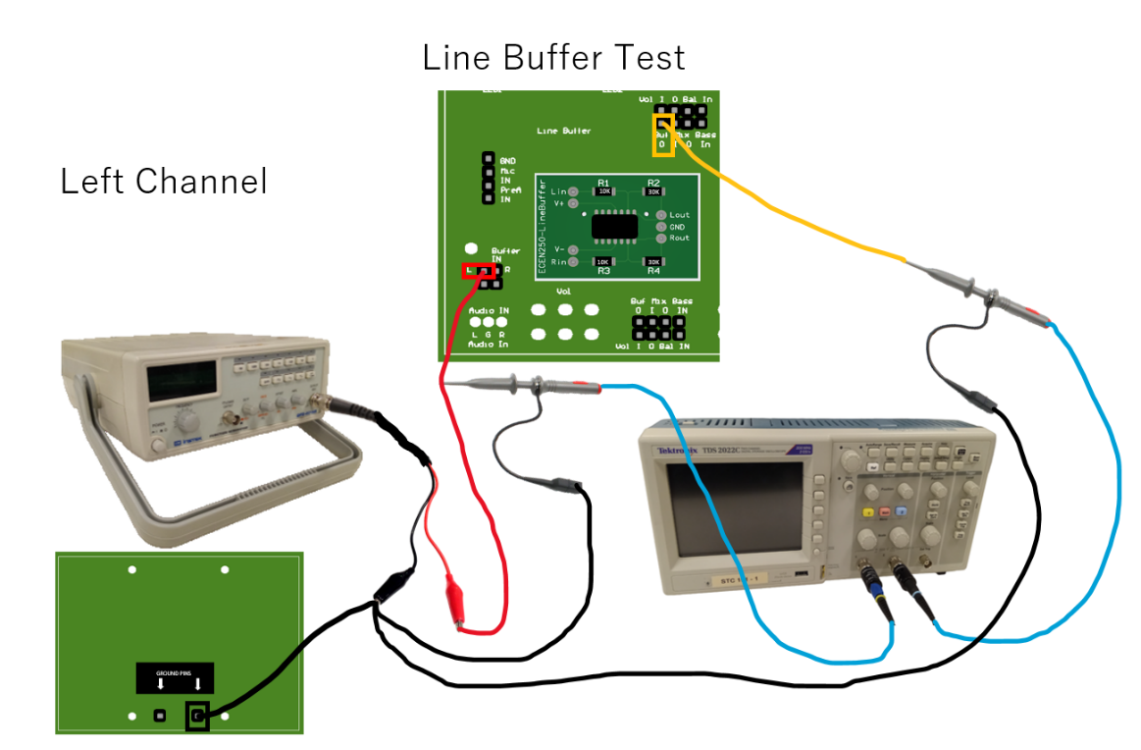

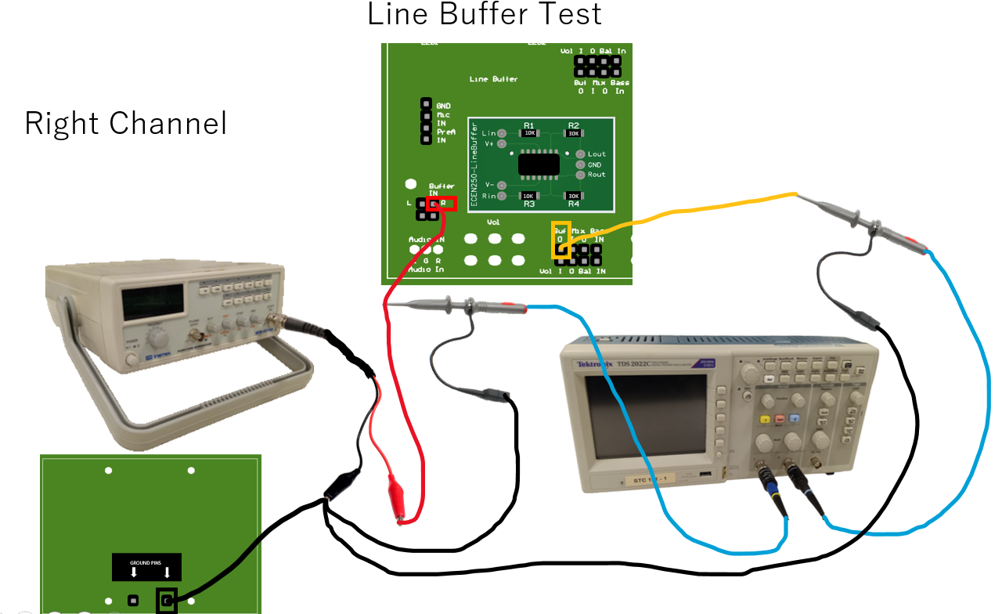

# **Preamp and Mixer PCB**

## Mixing Audio with the Microphone {Buffer PCB, and Preamp and Mixer}

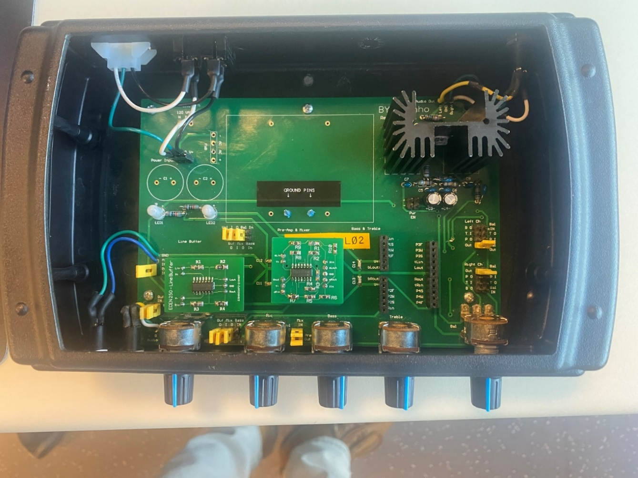

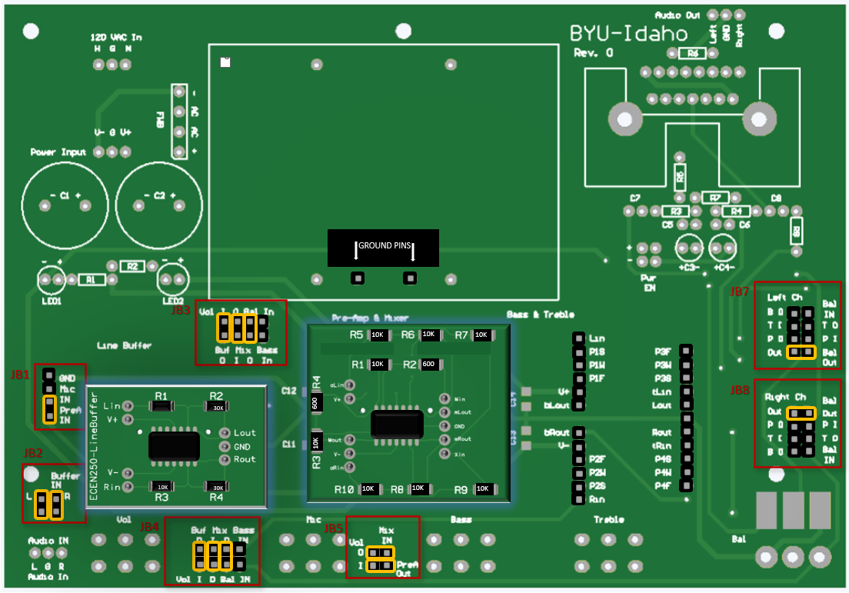

## **Pins to access to take preamp measurements.**

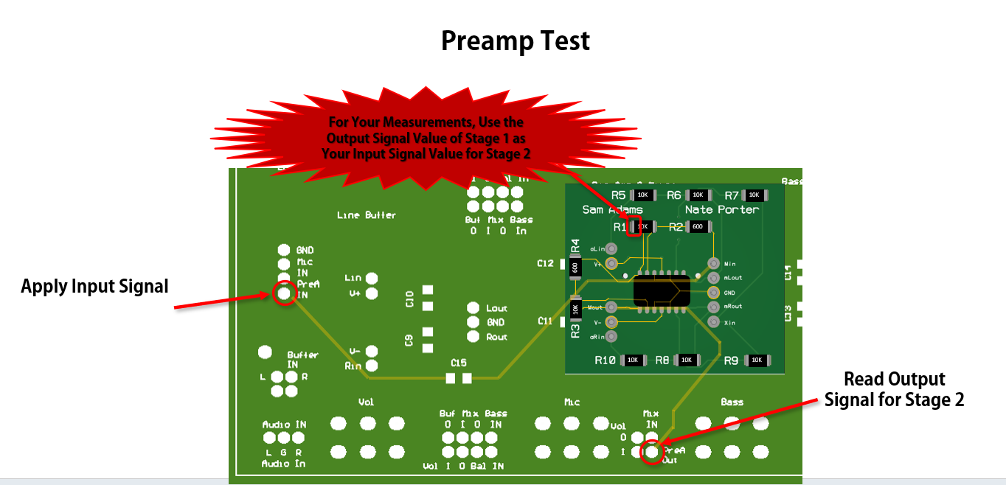

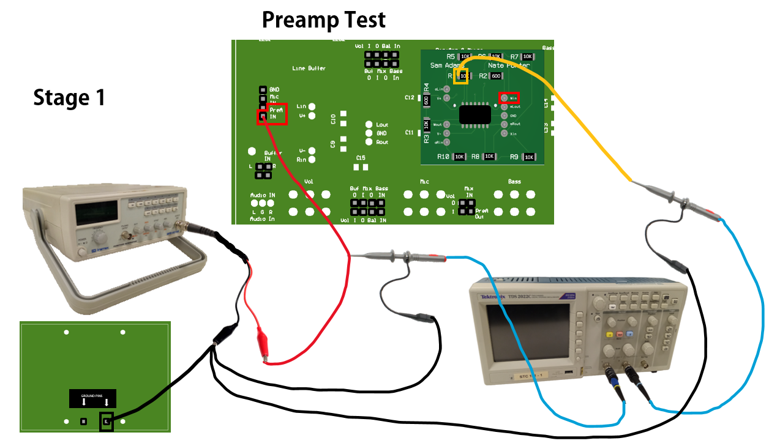

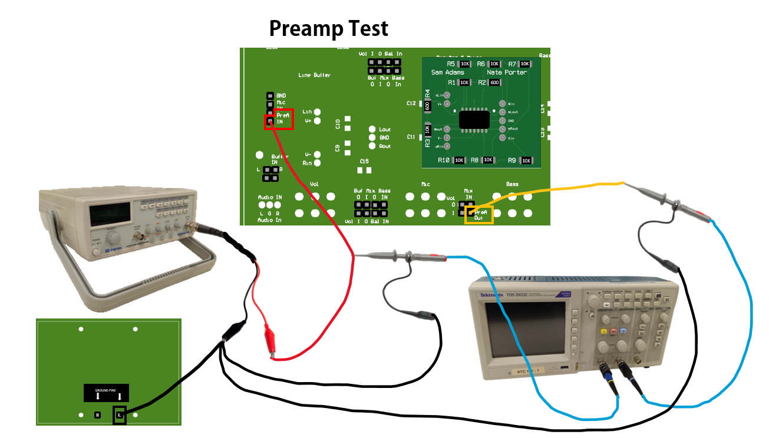

## **Pins to access to take mixer measurements.**

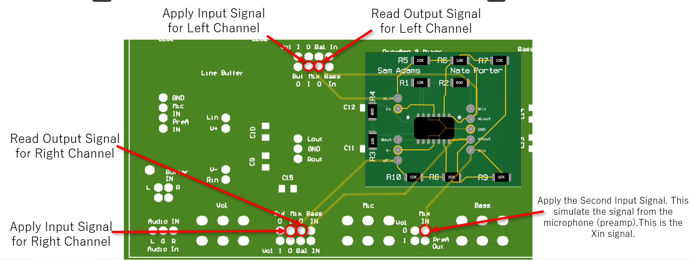

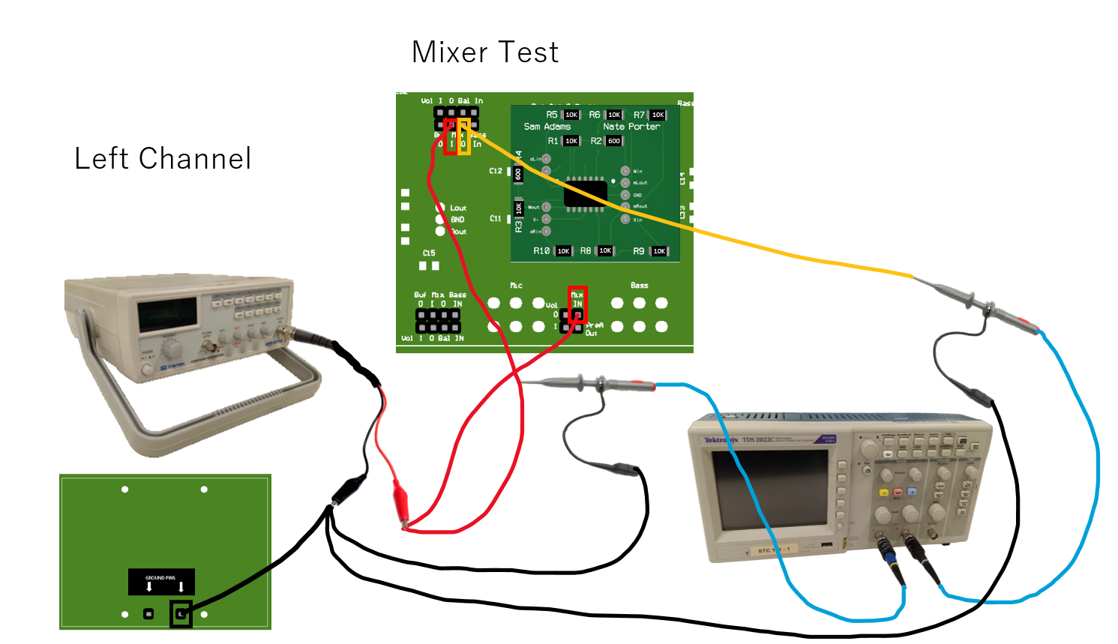

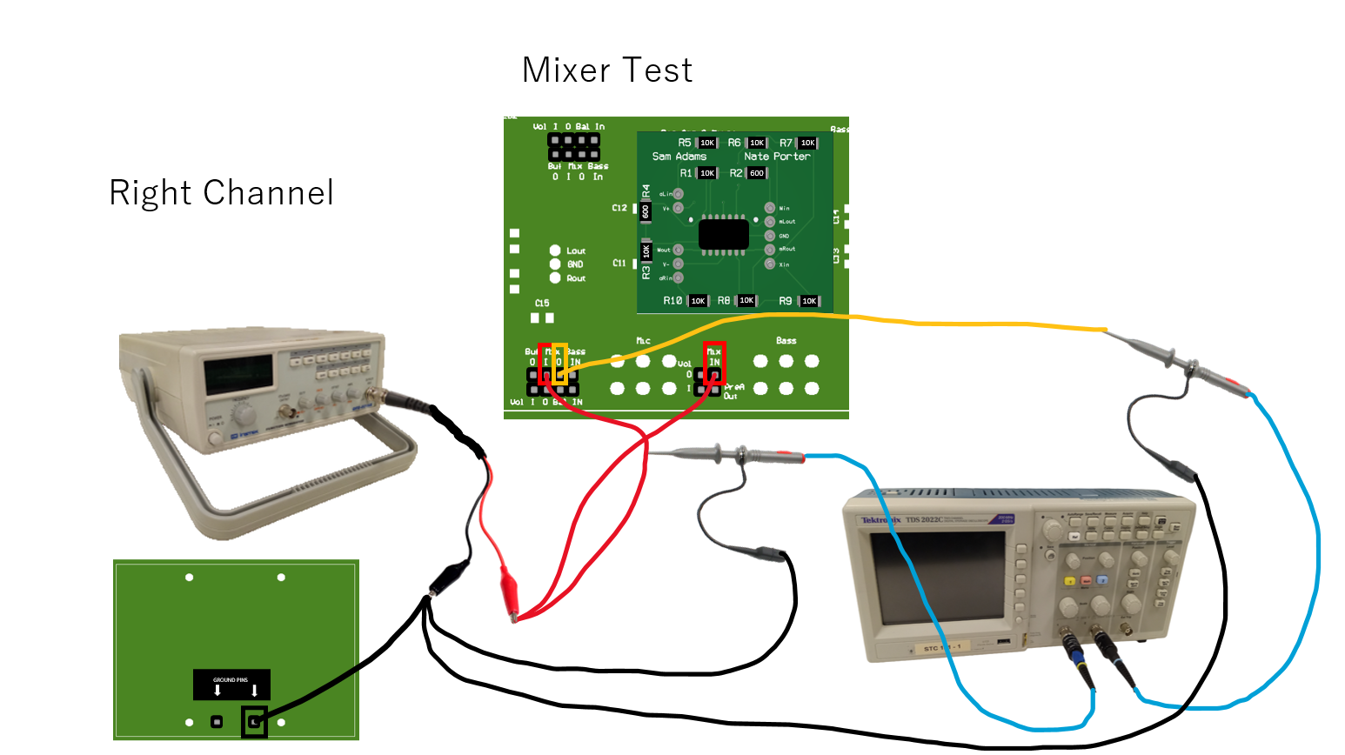

# **Treble and Bass PCB**

## Complete Stereo Amplify with Treble and Bass {Buffer PCB, Mic. Preamp and Mixer PCB, and Treble & Bass PCB}

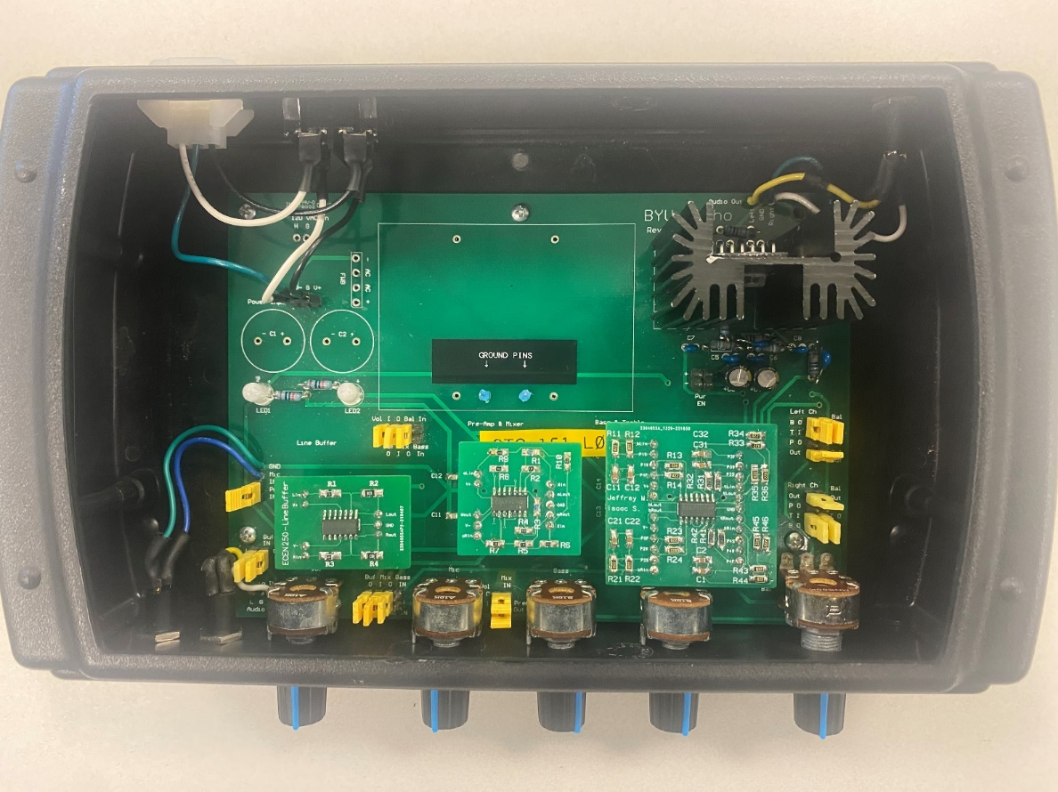

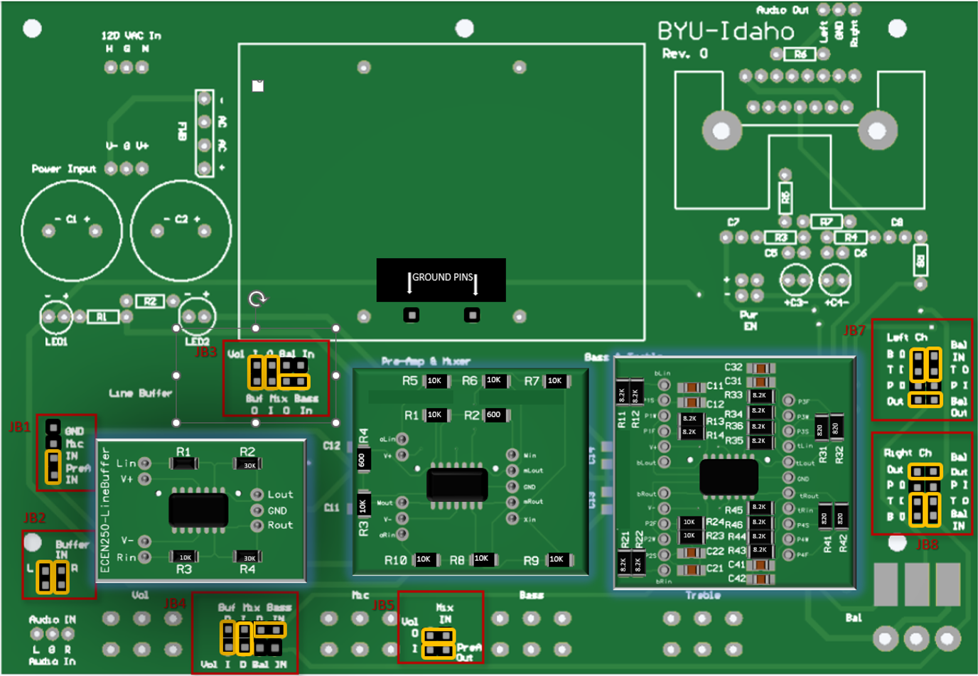

## 

## Pins to access to take Treble measurements.

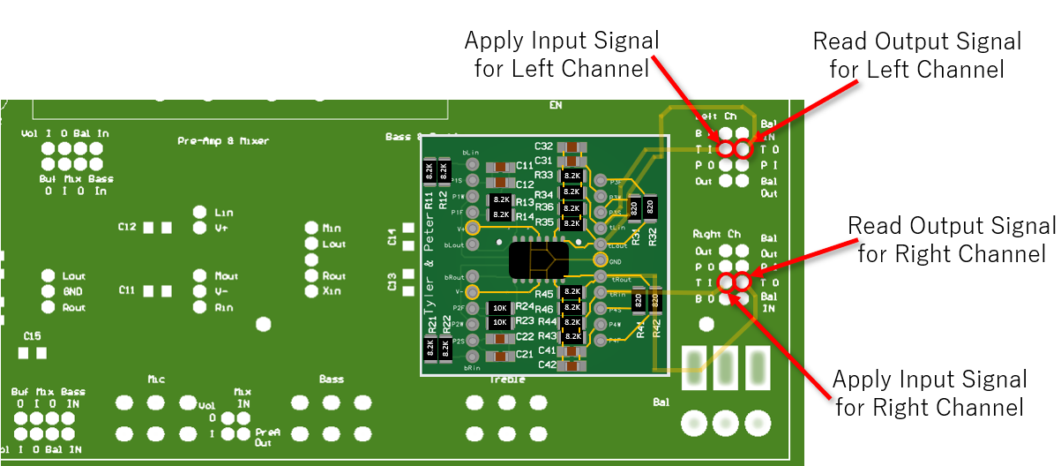

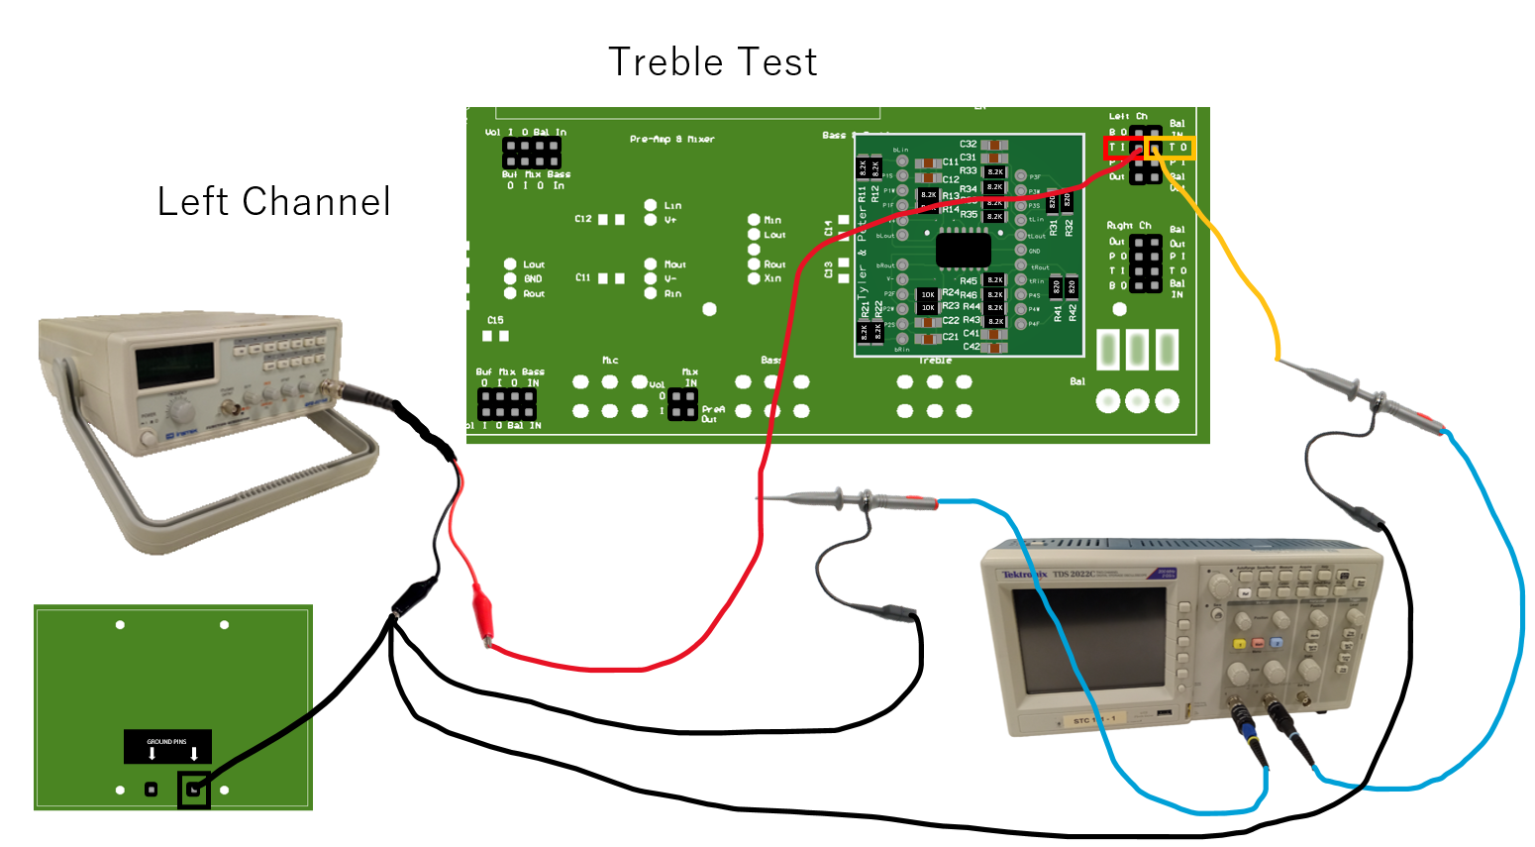

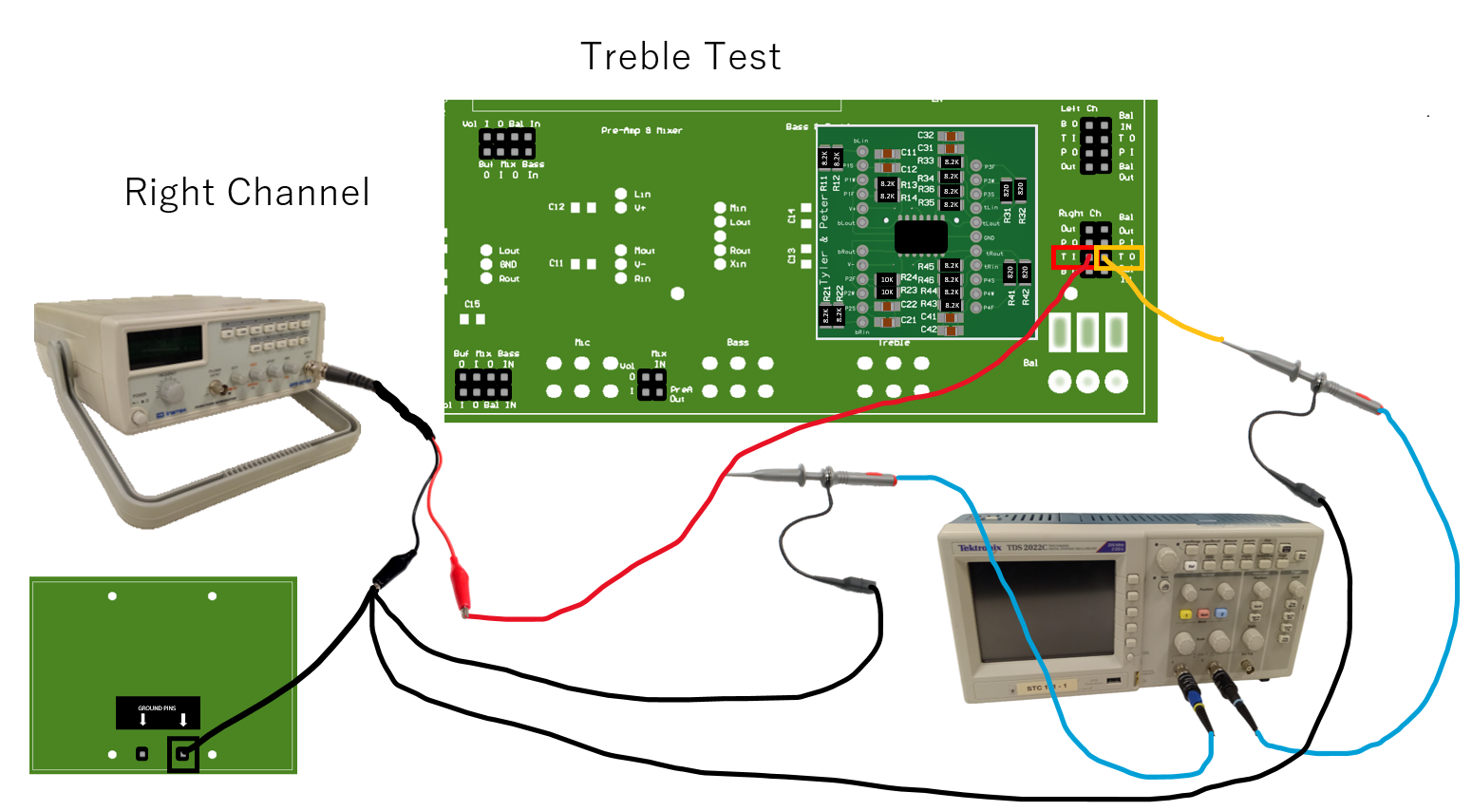

## Pins to access to take Bass measurements.

